**Design and Simulation of a Fuzzy Logic ABS Controller for Vehicle Stability**

Alexis Lechuga de los Santos

André Alberto Contreras Rivera

December 26th, 2021

# Introduction

The challenge of this project was to design and implement a fuzzy anti-lock braking system, better known as ABS. ABS braking systems have many advantages and benefits. Many vehicles currently on the market contain advanced ABS braking systems, which are very complex.

The control could only use the signals provided by the sensors presented below:

* + Pressure sensor in the master cylinder.
  + Angular rate sensor on each wheel.
  + Inertial Measurement Unit (IMU).

## 1.1 Block Diagram

An anti-lock braking system was designed, which is described in detail in the block diagram shown in Figure 1.

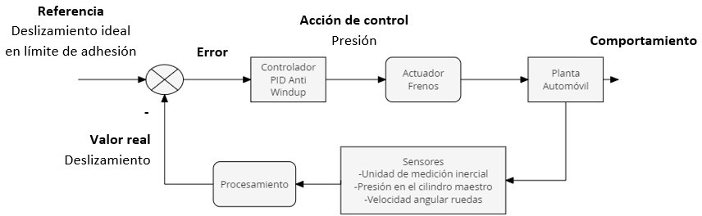

Figure 1: Block diagram of the system

We have an ideal slip reference value for the wheels; however, a calculation is required to obtain the actual slip of the wheels using the data obtained from the sensors and processing performed by the program.

This is done to obtain the slip error, which is then controlled by a fuzzy logic process that generates a control action for the brake caliper pressure.

In addition to this, we added a turning control block in which the information is processed both from the turn calculated in the same way by the processing in the program of the information from the sensors, as well as the control action generated in the fuzzy logic control block, this to generate an additional control action that will be integrated when necessary on the car's brakes to try to avoid the turn.

The operation of both the overall system and each of the aforementioned blocks will be explained in more detail later, as well as the reasons and rationales we used when making the design decisions for our system.

# Design Decisions

## General operation of the system

The first decision taken regarding the system design was the variable to be controlled, opting, as already mentioned, to control the slippage of each of the wheels to increase the vehicle's traction on the road and, above all, prevent the wheels from locking or skidding, thus improving the vehicle's braking parameters.

Likewise, we selected the pressure exerted on each of the brake calipers as the variable to be manipulated and decided to monitor the sensor values for each of the wheels separately and also generate a specific control action for the pressures of each of the brake calipers.

## Reference Slip value

To reduce braking time and distance, we want the wheels to have the maximum possible adhesion to the road, and since the slip value where this maximum adhesion is achieved is the one found at the limit of the transition between adhesion and complete slippage of the wheel (preventing it from locking), we place our slip reference just before this limit.

For the selection of the specific value, we tested the performance of the system with different values for the slip from 0.15 to 0.25, with an interval of 0.05, obtaining that for our case the best performance was given with a slip of 0.2, a value that approximately coincides with the location of the smax in the slip graph with respect to the force shown in figure 2.

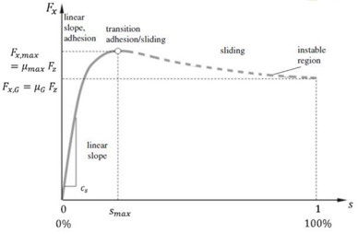

Figure 2: Graph of slip versus force

## Slip Monitoring

To obtain the slip we decided to use the formula for a wheel being braked, where the difference between the longitudinal and tangential speed resulting from the angular speed of the wheel multiplied by its radius is divided by the longitudinal speed.



The longitudinal velocity was obtained from the approximation to the integral of the longitudinal acceleration provided by the Inertial Measurement Unit, an approximation that was carried out using the Riemann sum, where the sum of the rectangles formed in the area under the curve is made, taking as the base of each rectangle the value of the sampling time ∂T and as the height the value of the longitudinal acceleration in that iteration

To obtain the radius originally and as would happen if the vehicle model were not available or the dimensions of the wheels were not known, we consider that at moments before braking, ideal conditions are met where it can be assumed that the longitudinal speed is equal to the tangential speed of the wheel, so the value of the radius could be approximated by solving it with the following formula.

V = ω · R → R = ω V

Adding that preferably the value of the angular velocity of the wheels on the axles where the vehicle has traction should be taken, since they would more closely resemble the behavior of the wheels in pure rolling.

But later, when investigating the vehicle model blocks, it was found that the radius could be linked to a constant K, in a segment in which this same relationship was carried out where the longitudinal speed is equal to the tangential speed of the wheel.

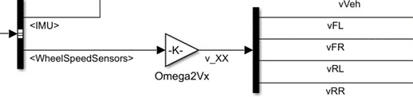

Figure 3: Wheel speed sensor diagram in Simulink

## Control Logic

On this occasion, a fuzzy logic controller was developed to control the pressure applied to the calipers on each of the car's wheels. To do so, we relied on a series of theories for modeling, control, computational algorithms, and artificial intelligence, all of which are based on uncertainty or imprecision reasoning without cutting boundaries.

Our fuzzy logic control block is represented as follows:

Figure 4: Block diagram of a fuzzy logic controller

The image shows the different stages that make up the fuzzy controller, including the fuzzification of the input data (membership functions), which will be controlled by the fuzzy rules that will determine the important information, and finally our defuzzifier from which our output signal will come out to control, in our case, the pressure applied to the tires.

In addition, we added a control block to be able to cancel or counteract the steering that occurred during the test simulation due to the conditions of the test, a block that will also be explained in more detail later.

The diagram below represents our anti-lock system, plus the proposed fuzzy control, and additionally the simple controller to prevent excessive car steering that we added.

Figure 5: Block diagram of fuzzy anti-lock brake system

# Membership Features

Membership functions (MFs) represent the degree of membership of an element in a subset defined by a label.

There are a wide variety of shapes for membership functions, the most common being trapezoidal, triangular, and singleton.

Figure 6: Formulas to obtain membership functions

For our system, we decided to use the triangular method to calculate the slopes of each set. We used the “x-a/b-a” function for the ascending phase and “c – x / c – b” for the descending phase, assigning a value of 0 or 1 when they were inside or outside certain vertices.

Our membership functions represent the slip error calculated by the program with each iteration of processing the sensor signals.

Figure 7: Input and output membership functions

Where the upper graph represents the Input MF: Large negative error (Eng), Medium negative error (Enm), Small negative error (Enp), Zero error (Ec), and Small positive error (Epp). And the lower graph represents the Output MF: in relation to the Master Cylinder pressure None (nPmc), Little (pocaPmc), Medium (mPmc), Almost all (casiPmc), and All the Master Cylinder pressure (Pmc).

# Fuzzy rules and control curve

Fuzzy rules are control conditions related to the slip error determined by the membership functions and the assignment of the pressure value to be applied by the master cylinder as indicated by these rules. This generates the control curve, along with the membership functions we defined for both the input and output, which is very helpful in visualizing the controller's potential response to a given input.

The fuzzy rules and the obtained control surface graph are shown below:

Figure 8: Fuzzy rules

Figure 9: Control surface

# Fuzzification

In fuzzification, degrees of membership are assigned to each of the input variables in relation to the previously defined fuzzy sets using the associated membership functions (Figure 10).

Figure 10: Fuzzification of input membership functions

This is where we obtain the position of the slip error (err) within the array containing the errors for each pneumatic. We then evaluate the slip error at that index to find the exact error at that moment for each membership function where that value (Ec, Epp) intercepts, and then use it in the inference. It's worth noting that functions that don't intercept with that value have a result equivalent to zero, or a flat line on the x-axis.

# Mamdani inference method

In this method, we must obtain the minima of the output membership functions using the previously calculated exact error points (Ec, Epp); in other words, we must "cut" the output membership functions at the exact error points calculated in the fuzzification, as shown in the following figure.

Figure 11: Mamdani's inference method

Obtaining trapezoid-like figures in the resulting output membership functions, as shown in Figure 12.

Figure 12: Exit membership functions cut off

Next, we must obtain the maximum of the previously calculated minimums, which leaves us with an irregular shape resulting from the trapezoid-like figures. The following graph shows this irregular shape (which is the graph with the maximums and minimums of the output membership functions).

Figure 13: Graph resulting from the inference

# Defuzzification

Known as "Fuzzy Reasoning," in this control stage we find the crisp value that is output to the process. In our case, we use the centroid method, in which a fuzzy set is used as the output of the aggregation stage, and a specific value is required (the value of the center of the area under the curve).

In our case, for the method coding we use the formula that is the sum of the multiplication of each of the values of the fuzzy set that we call “union” evaluated in each of the values of the vector “y” multiplied by each of the values of the vector “y”, divided by the sum of the multiplication of each of the values of the “union” set evaluated in each of the values of the output vector (see the following image).

Figure 14: Formula to obtain the centroid

As you can see, the centroid is close to the value of 0.9:

Figure 15: Location of the centroid in this example

# Yaw Control

For the vehicle's turning control, the Yaw was calculated from the integration of the Yaw Rate, which was carried out using the principle of calculating the area under the curve with the Riemann sum, having the sum of the rectangles with base dT and height Yaw Rate (see illustrative image).

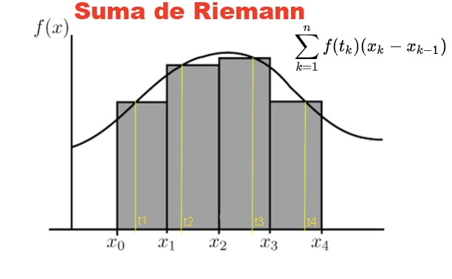

Figure 16: Illustrative example of Riemann summation

In the absence of adjustments through the steering system and the steering wheel, the way we devised to induce a turn in the opposite direction to the detected turn of the car to counteract it is by making the wheels that remain on the inside of the steering wheel in the direction in which we want to trace the curve act as a kind of pivot.

To achieve this, within this control block, conditions were created to adjust the pressure of the tires required as pivots using a proportional constant, calculated by the fuzzy logic control block, with a fixed setting according to the steering direction and friction.

Figure 17: Exemplification of the turn by means of a pivot

That is, if the car's turn is detected to the right, the left side tires would be sought to have greater braking than those on the right side to cause a turn to the left that would counteract the existing one, and to do so considering that the friction between these wheels and the pavement is greater, the pressure exerted on those tires is increased, fulfilling this objective. On the other hand, if the turn detected was to the left side, the right side tires would be sought to brake more and although the most logical thing would also be to apply greater pressure on those wheels, it was detected that this actually causes them to slip because their coefficient of friction is much lower, so after many tests and validations, it was decided to reduce the pressure on those tires, which actually caused them to not slip and therefore had greater braking than those on the opposite side.

When a left turn is detected in the vehicle, the pressure value for the right wheels calculated at the output of the fuzzy logic controller is multiplied by a constant of 0.6, while when a right turn is detected, the pressure value for the left wheels calculated in the fuzzy logic controller is multiplied by a constant of 1.4.

# Validation and progress

**3.1** **Validation test**

On this occasion, the test performed for our proposed anti-lock braking system was as follows:

INIT_SPLIT70 TEST

The driver applied the panic brake at 70 km/h (43 mph), while the car was already on a divided surface, meaning the right-hand wheels had a much lower coefficient of friction than the left-hand wheels, in this case because they were on dirt and pavement respectively.

The values of the detailed conditions are as follows:

* + 1. Initial speed: 70 km/h (+/- 2 km/h)
    2. Turning angle: 0° (constant).
    3. The brake pedal is fully applied. The driver releases the steering wheel and the vehicle remains at 0°.
    4. μ = [0.90, 0.4] (left, right)

**3.2** **Progress**

Throughout the project, many changes were made, but there were certain modifications that had a significant impact on the performance of our system.

To begin with, the fuzzy rules we had originally defined did not contemplate having an output pressure with a value close to zero, which meant that, since it was unable to reduce the existing slippage on the wheels since doing so required a lower pressure value than we had established, the controller would stabilize at the lowest value we had defined as the output. This was undesirable and resulted in little improvement compared to the system without the ABS activated. This is shown in the following figure.

Figure 18: Main Scope graphs in Simulink (acceleration, velocity, and tire pressure)

Subsequently, once that problem was resolved and the rules were adjusted, we noticed that the membership functions we had defined were as follows:

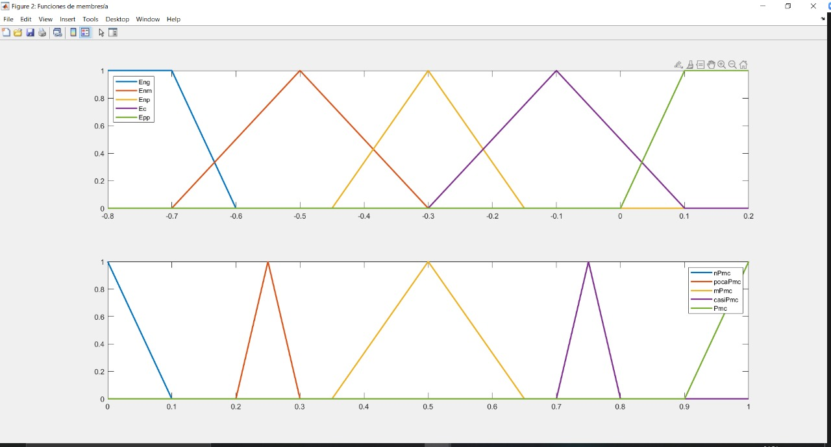

Figure 19: Input and output membership functions

They had room for improvement, as we noticed that control over the slippage of the left wheels could be improved, considering that they were the ones not as affected by the simultaneous control implemented to counteract the turn and since they had the highest coefficient of friction so that they could reach the desired slip value of 0.2 more quickly, as can be seen in the following image.

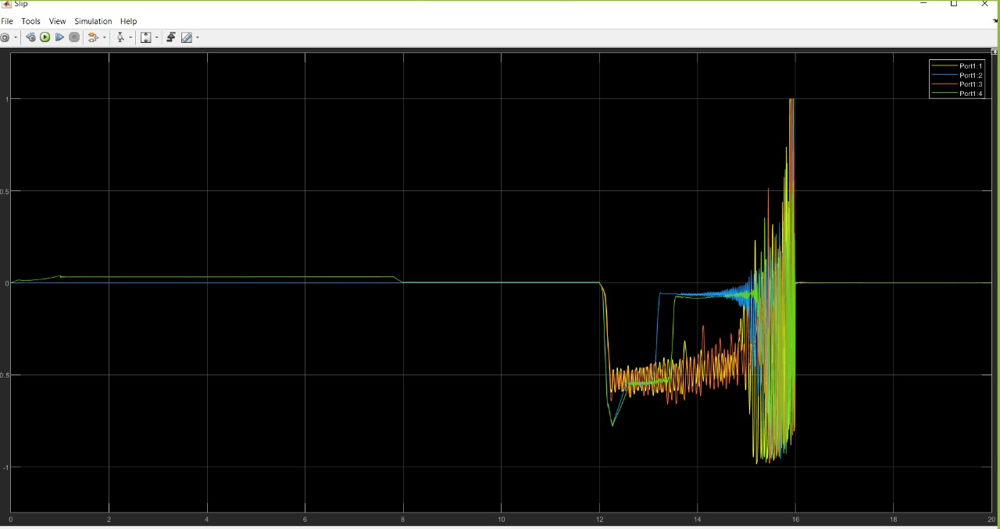

Figure 20: Slip graph in Simulink of the test

We therefore modified the membership functions several times until we arrived at those shown in section 2.4.1, which gave us the best results.

Additionally, we modified the proportionality constant used within the turning control block several times, until we reached those shown in section 2.4.6, which also gave us the best results.

# Best Results

After all the modifications made to our system and the 2 control blocks, the best results obtained were the following:

Figure 21 y 22: Comparison of braking time and distance with the anti-lock system activated and deactivated respectively.

Specifically, the best performance of the test was:

* 30.09% reduction in braking time
* 34.83% reduction in braking distance
* Reduction in swerving and staying within lane limits

Below are the graphs of this:

Figure 23: Slip graph in Simulink of the best result

Figure 24: Main Scope graphs in Simulink (acceleration, speed, and tire pressure) of the best result

As can be seen in Figure 24, in the Scope graph at the beginning of braking (approximately at second 12), pressure begins to be applied at MC. The action of the fuzzy controller keeps this pressure below what the driver applies to each tire; this way, control is optimized (ideally) to maintain the desired slip and reduce speed in a shorter time.

Additionally, in this test, there are variations in the car's lateral acceleration because the right wheels of the car leave the ground, which produces a lot of steering because the coefficient of friction is different, and when the brake is applied, a difference occurs between the speeds of each of the tires. Furthermore, between our fuzzy controller and the one developed for cornering, there are times when they do not integrate well with each other, affecting wheel slip, which is why we sometimes obtain values (such as 0.5) that are different from those expected (0.2).

In the Slip graph shown in Figure 23, at the beginning of braking, slippage begins to increase, and distinct variations in the slippage of each tire are seen. This is because the fuzzy system applies different pressures based on sensor information and the programming of this type of control. As braking progresses, slippage decreases until the movement ends.

# Conclusions and areas of opportunity

Based on the progress made in developing our proposal for the anti-lock braking system and the results of the various tests we conducted, as well as the resolution of the obstacles we encountered, we can conclude the following:

1. *Importance of the location of MFs and control rules.*

It is important to define the fuzzification rules and membership functions as efficiently as possible to achieve better control of the output signals, since they directly affect the pressure applied to each wheel relative to the pressure applied by the driver to the master cylinder. The better the definition of the membership functions, the better the system's performance.

1. The control surface or curve in our case helps to identify how to optimize performance.

A control curve or surface can help us develop a program that shows greater performance when applied to a system like ours. If we can identify how to optimize control, we can reduce both tangible and intangible (time) costs.

* Adjust to more precisely maintain slip at the desired value of 0.2 on wheels with the lowest coefficient of friction.
* Steering control that, instead of being fixed, is adaptable through another control method, for example, PID or fuzzy logic.
* Optimize the simultaneous integration of slip and yaw control, especially without the latter affecting the performance of the former at any time.
* Better results could be obtained by considering the distribution of braking between axles.